At a special meeting of the Township Board for White River Township held at the Montague High School Auditorium, 4900 Stanton Blvd., Montague, MI on Wednesday, April 26, 2023, at 6:00 p.m., the following Ordinance/ordinance amendment was offered for adoption by Township Board Member Deb Harris and was seconded by Township Board Member Dufresne:

**AN AMENDMENT TO THE WHITE RIVER TOWNSHIP ZONING ORDINANCE REGARDING SOLAR PANELS, SOLAR ENERGY SYSTEMS, AND RELATED USES AND MATTERS.**

THE TOWNSHIP OF WHITE RIVER (the "Township") ORDAINS:

Article 1. The following new definitions are hereby added to Chapter 2 of the White River Township Zoning Ordinance where they fall alphabetically (and the prior definition of “Solar Energy System” is replaced with the new definition as follows):

SOLAR ENERGY SYSTEMS (SES): Solar energy collectors, panels, parts, controls, poles, posts, energy storage devices, heat pumps, heat exchangers, and/or other materials, items, hardware, and/or equipment necessary to the process by which solar radiation is collected, converted into another form of energy, stored, protected from unnecessary dissipation, and distributed. Solar energy systems include solar thermal, photovoltaic, and concentrated solar. This definition does not include small devices or equipment such as solar powered lawn or building lights which house both the solar energy generation system and the system which uses that energy to operate.

* * *

Building-Mounted Solar Energy System: A solar energy system attached to the roof or wall of a building, or which services as the roof, wall, or window or other element, in whole or in part, of a building.

* * *

Ground-Mounted Solar Energy System: A solar energy system that is not attached to and is separate from any building on the parcel of land on which the solar energy collector is located.

* * *

Maximum Tilt: The maximum angle of a solar array (i.e., most vertical position) for capturing solar radiation as compared to the horizon line.

* * *

Non-Participating Lot(s): One or more lots for which there is not a signed agreement, lease or easement for development or use of a utility-scale solar energy system.

* * *

Participating Lot(s): One or more lots under a signed agreement, lease or easement for development or use of a utility-scale solar energy system.

* * *

Prime Agricultural Soils or Areas: Shall mean one, some or all of the following:

1. Any land or property in a contract or program pursuant to Michigan Public Act No. 116 of 1974, as amended, being MCL 324.36101 *et seq*. (commonly called “PA 116”).
2. Any land or property in or subject to a conservation easement, farmland preservation agreement or the equivalent.
3. Any land or property shown as “prime farmland” on a current or future White River Township Master Plan Map (entitled Prime Farmland).
4. Any land or property identified as prime farmland by the Natural Resources Conservation Service (NRCS) of the U.S. Department of Agriculture (USDA).

* * *

Small-Scale Solar Energy System: A solar energy system primarily intended to provide energy for on-site uses and to provide power for use by owners, lessees, tenants, residents, or other occupants of the lot on which it is erected. It may be comprised of the following: building-integrated photovoltaic systems, flush-mounted solar panels, ground-mounted solar energy systems, or building-mounted solar energy systems. It shall not exceed two-thousand (2,000) square feet in size.

* * *

Solar Energy Collector Surface: Any part of a solar energy system that absorbs solar energy for use in the system’s transformation process. The collector surface does not include frames, supports, and mounting hardware.

* * *

TOTAL AREA (AS WELL AS LOT COVERAGE, LAND AREA, COVER, OCCUPY AND/OR SIZE): When used in association with or pertaining to a solar energy system shall mean the total area of all components and parts of the solar energy system and facilities (including the solar panels as if they were laying flat on the ground) on a lot or parcel within the outer periphery of those facilities as viewed from above or a bird’s-eye view. Such area shall include the area contained within the shortest line surrounding all of the solar facilities on a lot as viewed from above or a bird’s-eye view and as if all of the solar panels were laying flat on the ground. Vacant or unused land between and/or among solar panels, solar fixtures and solar facilities shall also be considered part of the coverage or total area. Please also see the following figures:

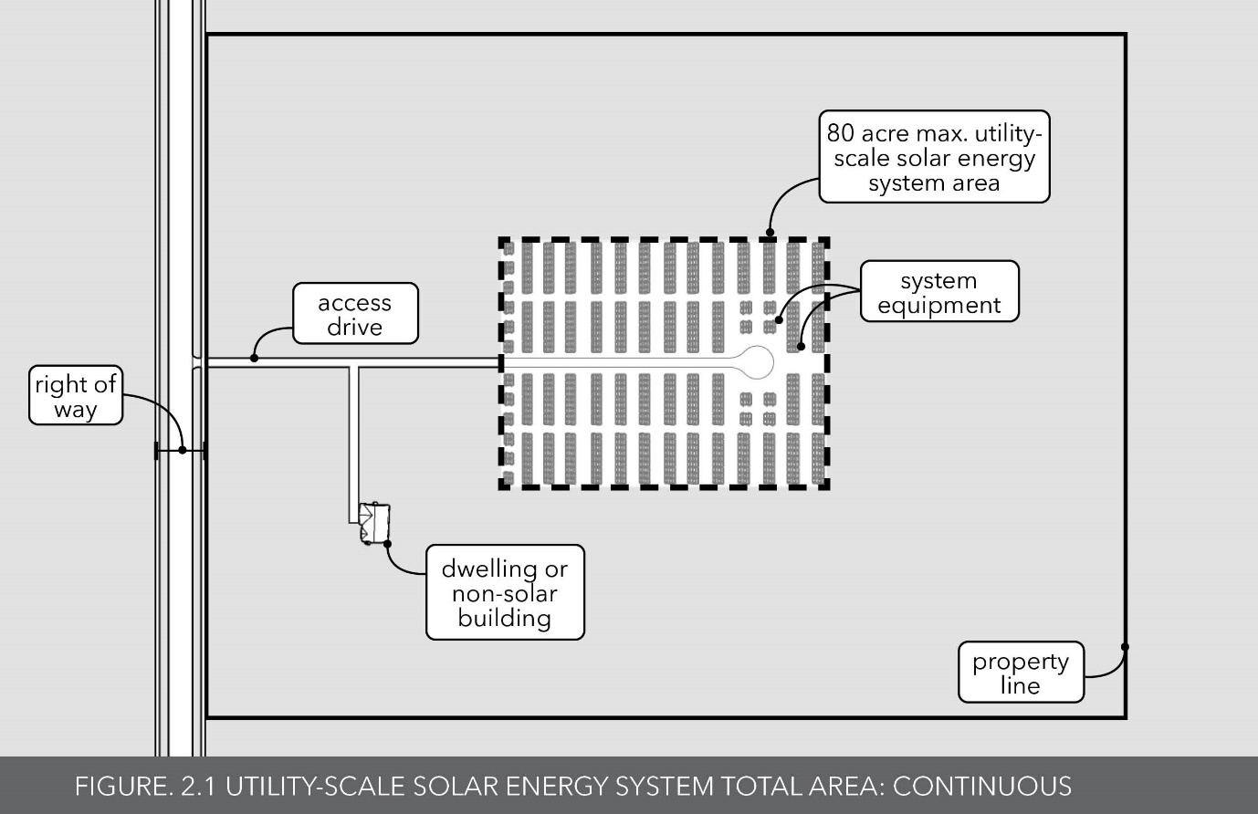

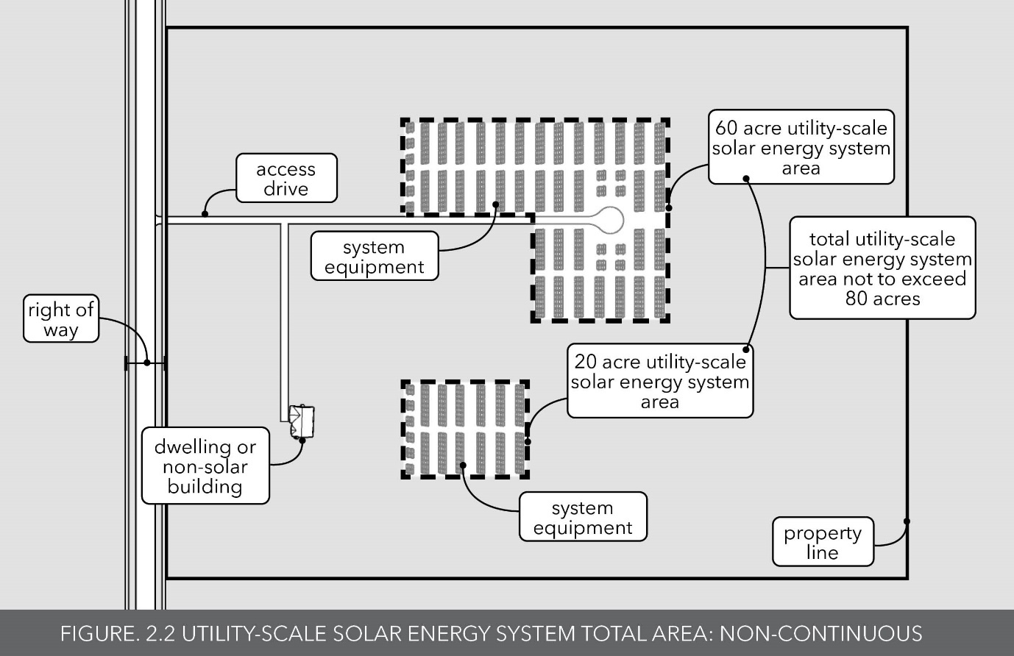

* * *

Utility-Scale Solar Energy System: A solar energy system that meets one or more of the following:

* 1. It is primarily used for generating electricity for sale and distribution off site to an authorized public utility, other utility or firm for use in the electrical grid;
  2. The total surface area of all solar collector surfaces exceeds two-thousand (2,000) square feet; and/or
  3. It is a principal use or principal structure on a parcel.

* * *

Article 2. Existing Section 3.45 of the White River Township Zoning Ordinance is replaced in its entirety with the following language:

SECTION 3.45 SMALL-SCALE SOLAR ENERGY SYSTEMS.

1. Applicability. This section applies to small-scale solar energy collector systems as defined by this Ordinance. This section does not apply to solar energy collectors mounted on fences, poles, or on the ground with collector surfaces less than five (5) square feet and less than five (5) feet above the ground, nor shall it apply to a solar energy system used to power a single device or specific piece of equipment such as a lawn ornament, light, weather station, thermometer, clock, well pump, or other similar device. Further, this section does not apply to utility-scale solar energy systems, which are regulated in Section 16.06MM of this Ordinance. Regardless of whether a particular provision of this Section 3.45 refers to the applicant, the lessee of land or the landowner, the property owner or landowner is ultimately responsible for compliance with this Ordinance.
2. General Requirements. The following shall apply to all small-scale solar energy systems (except where a stricter requirement is specified elsewhere by this Ordinance):
3. Permit Required. No small-scale solar energy system shall be installed or operated except in compliance with this section. A zoning compliance permit shall be obtained from the Zoning Administrator prior to the installation of a small-scale solar energy system. All small-scale solar energy systems shall be constructed, installed, used, operated, and maintained in strict accordance with the Michigan Building Code, the Electric Code, and the manufacturer’s specifications.
4. Applications. In addition to all other required application contents as required by this Ordinance, applications for a small-scale solar energy system shall also include equipment and unit renderings, elevation drawings, and a sketch drawing depicting all lot line setbacks and the location of devices.
5. Setbacks. Every component and part of a small-scale solar energy system shall be set back a minimum of fifteen (15) feet from the side and twenty-five (25) feet from the rear property boundaries, as well as fifty (50) feet from the front property line.
6. Location. No component or any part of a small-scale solar energy system shall be in the front yard of a residential zoning district. In addition, in the WR – Waterfront Residential and CDO – Critical Dune Overlay zoning districts, no solar energy system component or part shall be located on the waterfront side of the property, including wall surfaces facing the water.
7. Noise: No solar energy system generating component shall emit noise exceeding forty-five (45) dBA, as measured at the parcel's property boundary or at the public or private road right of-way or easement.
8. Glare: All solar energy system location/tilt components shall be designed, maintained and operated to avoid glare and reflection of sunlight and other artificial lighting which may affect navigation by air, water, and roadway. Solar energy system designs shall comply with all Federal Aviation Administration siting requirements.
9. Power lines. On-site power lines between solar panels, buildings, and inverters shall be placed underground.
10. Security. Security for components of a solar energy system is the responsibility of the property owner.
11. Following the operational life of the small-scale solar energy system, or the abandonment or cessation thereof (whichever occurs first), the property owner shall promptly perform decommissioning and removal of the small-scale solar energy system and all components and parts. At all times, while any of the small-scale solar energy system components or parts are present on the property, broken solar panels shall be promptly repaired or removed from the site. There shall be no on-site storage of broken or malfunctioning solar panels.
12. Building-Mounted Solar Energy Systems. Building-mounted solar energy systems may be established as an accessory use in all zoning districts subject to the following conditions.
    1. Maximum Height: Building-mounted solar energy systems shall be attached directly to the building and shall not be higher than the peak of the building to which they are attached.
    2. Obstruction and Placement: Building-mounted solar energy systems shall not obstruct solar access to adjacent properties and shall not project beyond the eaves of the roof.
    3. The installation of a building-mounted solar energy system on a nonconforming building, structure, lot, or use shall not be considered an expansion of the nonconformity.
13. Ground-Mounted Solar Energy Systems. Ground-mounted solar energy systems may be established as an accessory use subject to the following conditions:
    1. Ground-mounted solar energy systems are allowed as follows:
       1. Ground-mounted solar energy systems are allowed in any zoning district so long as they do not exceed one-thousand (1,000) square feet in area in total on any lot or parcel.
       2. Ground-mounted solar energy systems between one-thousand (1,000) square feet in total area per lot or parcel and two-thousand (2,000) square feet in total area per parcel or lot are allowed in any zoning district with special land use approval, subject to Section 16.06MM of this Ordinance.
       3. Ground-mounted solar energy systems that equal or exceed two-thousand (2,000) square feet in total area on a given lot or parcel are only allowed within the C - Commercial, LI, Light Industrial and A - Agricultural zoning districts and must be approved as a special land use, subject to Section 16.06MM of this Ordinance.

[For determining the total area of a solar energy system, see the definition of Total Area (and others in Chapter 2) of this Ordinance.]

1. Lot Coverage: The total amount of lot coverage of solar energy systems is limited to 20% of the total area of the parcel involved when the parcel is in the R – Residential, WR — Waterfront Residential or CDO — Critical Dune Overlay zoning districts. For determining lot coverage, see the definition of Total Area (and others in Chapter 2) of this Ordinance.
2. Height: The maximum height of a ground-mounted solar energy system device shall not exceed twelve (12) feet above natural grade below the unit to the highest point at maximum tilt.
3. The regulations and requirements for a utility-scale solar energy system are contained in Section 16.06MM of this Ordinance.

Article 3. A new and additional Subsection 16.06MM is hereby added to the White River Township Zoning Ordinance that reads as follows:

MM. Utility-Scale Solar Energy Systems.

* 1. Purpose. White River Township finds that the production of energy through the installation of solar energy systems is a matter closely connected with the public health, safety, and welfare of the community. The purpose of this Section is to strike an appropriate balance between the interests of community residents, real property owners, and businesses interested in harnessing the energy of the sun through the installation and use of utility-scale solar energy systems. While the creation of domestic local energy sources brings benefits to the state, region, and community, the installation and use of utility-scale solar energy systems simultaneously creates concerns surrounding farmland preservation, community aesthetics, environmental impacts, wildlife impacts, property value impacts, noise, glare, public health, and other similar issues. Further, the dominance of one particular land use brings aesthetic and economic concerns and the impact on the viability of historic land uses such as farming in the community.
  2. Special Land Use. Special Land Use approval is required for all utility-scale solar energy systems and also for certain other solar energy systems as specified in Subsection 3.45 D hereof. The applicant shall also comply with all applicable federal, State of Michigan and county requirements, (including any requirements by the Muskegon County Water Resources Commissioner) in addition to other applicable Township ordinances and codes. All plans, drawings, or other material submitted for a utility-scale solar energy system special land use approval shall be produced by licensed professionals appropriate for the materials. In addition to the Special Land Use standards found in Section 16.03A of this Ordinance, the Planning Commission shall also consider the following:

1. The Special Land Use shall not significantly adversely impact the property values of buildings, structures and lands located within one mile of the solar facilities. A presumption arises that this standard will not be met if substantial evidence indicates that the proposed solar energy system or facilities will decrease the value of any parcels or lots (or the buildings, uses, land value or structures thereon) by 15% of fair market value or greater.
2. The Special Land Use will not visually, aesthetically, economically or otherwise dominate other area land uses, structures or activities.
3. The Special Land Use shall be harmonious and consistent with the intent of the Township Zoning Ordinance.
4. The Special Land Use will not establish a precedent for developments or uses which could adversely affect the long-term goals of the Township Zoning Ordinance and Master Plan.
5. The Special Land Use shall be designed to preserve environmental features, such as lakes, streams, flood plains, agricultural areas and natural areas.
6. The Special Land Use shall be reasonable.
   1. The applicant shall comply with State of Michigan Construction Code (as adopted by the county) and the National Electric Code (NEC). In the event of a conflict between the State Building Code and National Electrical Code, the NEC shall prevail.
   2. All components of a utility-scale solar energy system shall be approved by the Institute of Electrical and Electronics Engineers (IEEE), Solar Rating and Certification Corporation (SRCC), Electronic Testing Laboratories (EIL), or a similar certification organization.
   3. Setbacks: Setback distances shall be measured as follows:
      1. Every component and part of a utility-scale solar energy system, including required fencing, shall not be located within six-hundred (600) feet of any lot line or public or private road right-of-way or easement.
      2. If there is a residential use or dwelling on the parcel where a utility-scale solar energy system is located, any solar energy component or part, including required fencing, shall not be located within one-hundred (100) feet of the dwelling on that parcel.
      3. Any component or part of a utility-scale solar energy system, including required fencing, shall not be located within one-hundred (100) feet of a stream, river, pond, lake, wetland, drain, or lands located within a 100-year floodplain as identified by the Federal Emergency Management Agency (FEMA).
      4. A utility-scale solar energy system is not subject to property line setbacks for common property lines of two or more participating lots, except that front property lines, water, and road right-of-way setbacks shall still apply.
   4. Township Land Coverage: Utility-scale solar energy systems shall not occupy or cover more than five (5) percent of the total land area of White River Township. For determining land coverage, see the definition of Lot Coverage in Chapter 2 of this Ordinance.
   5. Maximum Size: Utility-scale solar energy systems shall not exceed eighty (80) acres in size per parcel or lot. For determining such maximum size, see the definition of Size in Chapter 2 of this Ordinance. In addition, where two (2) or more utility-scale solar energy systems (or the lots or parcels involved) are located within one (1) mile of one another and are owned or operated by the same person or firm (or a related or affiliate firm), such systems shall be deemed to be one overall utility-scale solar energy system for purposes of this Subsection 7 and the total size shall be attributable to each such lot or parcel. By way of explanation (but not of limitation), Parcel A has an existing utility-scale solar energy system that is 40 acres in size. Parcel B is located within one-half mile of Parcel A and the same property owner, firm or affiliate of the firm that owns or operates the utility-scale solar energy system on Parcel A is proposing a new 30 acre utility-scale solar energy system on Parcel B. The total of the land area for the existing and proposed utility-scale solar energy system would not exceed 80 acres, such that the maximum size limit would not be exceeded. Alternately, Parcel 1 has an existing utility-scale solar energy system that is 60 acres in size. Parcel 2 is located three-quarters of a mile from Parcel 1. The owner, firm or affiliated firm that owns or operates the utility-scale solar energy system on Parcel 1 is proposing a new 30 acre utility-scale solar energy system on Parcel 2. Accordingly, both Parcel 1 and Parcel 2 are deemed to have a utility-scale solar energy system with the size of 90 acres, such that the new utility-scale solar energy system cannot be built, installed or utilized on Parcel 2.
   6. Screening, Landscaping, and Visual Impact: Where a utility-scale solar energy system is located on a property that abuts a public or private road right-of-way or easement or property containing a non-participating residential use and such right-of-way or easement or residential use is not sufficiently screened by existing vegetation, the perimeter within 100 feet of the utility-scale solar energy facility and required fencing shall be screened and buffered by landscaped earthen berm, installed native evergreen hedge or densely leaved deciduous trees and shrubs, or combination thereof. Any perimeter fencing installed shall be located inside any berm or vegetative screening (see Subsection 16.06MM.10 for Security and Fencing requirements).
      1. Berms shall be a minimum of five (5) feet in height from the surrounding grade and shall be sloped to no more than a ratio of one (1) foot vertical to four (4) feet horizontal.
      2. Evergreen trees shall be a minimum of four (4) feet in height when planted, deciduous trees shall be at least a 2-inch caliper when planted, and shrubs shall be at least two (2) feet in height at the time of planting.
      3. Evergreen trees shall be spaced no more than fifteen (15) apart on center, deciduous trees shall be placed no more than thirty (30) feet apart on center, and shrubs shall be placed no more than seven (7) feet apart on center. The Planning Commission may modify required planting separations if it is determined that the combination of proposed landscaping, berming, and screening will not be sufficient to screen the project.
      4. The type, location, and configuration of such screen shall be approved by the Planning Commission and shall be maintained for the life of the project and dead or dying vegetation shall be replaced within one (1) year, as necessary, to maintain the visual screen.
      5. Plantings or berms shall be sufficient to visually screen the project. The applicant shall demonstrate the visual impact and screening opacity using photos or renderings of the project or similar projects.
   7. Ground Cover: Native pollenating plants shall be planted (and maintained) between solar panel rows as ground cover for bees, butterflies, birds, and other wildlife. A horticulturist or landscape architect shall be consulted and make recommendations for all plantings.
   8. Security and Fencing: Security for a utility-scale solar energy system requires a completely enclosed perimeter security fence to restrict unauthorized access. All fencing (including type, color, size, and location) shall be approved by the Planning Commission. Fencing shall not exceed eight (8) feet in height, unless approved by the Planning Commission. Use of barbed-wire on fencing is prohibited. Electric fencing is not permitted. Fencing more than eight (8) feet in height may be required to be set back further from the public or private road right-of-way or easement. Any substation or support structures and related electrical transmission equipment buildings shall be further secured with additional fencing and security measures, locks, and restricted access. Any public roadways or access points to the parcel shall have additional fencing and/or restricted access measures. The Planning Commission may require wildlife-friendly fencing with openings that allow wildlife to traverse over or through a fenced area.
   9. Agricultural Protection:
      1. Utility-scale solar energy systems shall generally not be located on or within prime agricultural soils or areas.
      2. For sites where agriculture uses or farms are a permitted use in the zoning district where the lot or parcel is located, a utility-scale solar energy system shall be sited so as to minimize impacts to agricultural production through site design and accommodations. The applicant shall follow the following protective methods, and provide reasonable evidence to the Planning Commission that the site will be reasonably capable of maintaining agricultural operations and/or a return to agricultural production upon decommissioning of the utility-scale solar energy system:
7. The ground mounting of panels by screw, piling, or similar system that does not require a footing, concrete, or other permanent mounting in order to minimize soil compaction;
8. Siting panels to avoid disturbance and compaction of farmland by siting panels along field edges and in nonproductive areas to the maximum extent practicable and financially feasible;
9. Maintaining all drainage infrastructure on site, including drain tiles and ditches, during the operation of the utility-scale solar energy system;
10. Siting the utility-scale solar energy system to avoid isolating farm operations such that they are no longer viable or efficient for agricultural production, including, but not limited to, restricting the movement of agricultural vehicles/equipment for planting, cultivation, and harvesting of crops, and creating negative impacts on support infrastructure such as irrigation systems or drains; and
11. Maintaining existing grading and topography on the site as much as practicable, including all soils except where needed to install footings or other infrastructure.
12. Prime agricultural soils and areas shall be avoided and not have utility-scale solar energy systems or components thereon unless no other land is reasonably available and the facilities will not adversely affect other area uses.
    1. Wildlife and Environmental Protection: The applicant shall provide information to ensure that impacts on wildlife, surface waters, groundwater, and other environmental concerns are addressed and minimized. Such concerns include, but are not necessarily limited to, impacts to protected and endangered species, impacts of perimeter fencing on deer and animal movement, impacts to protected wetlands, impacts on soils, and stormwater runoff. The Planning Commission may require the applicant to submit reports from the United States Fish and Wildlife Service and other environmental reports in this regard. Further, equipment and materials used in the utility-scale solar energy facility shall be widely considered safe and non-hazardous by relevant industry standards, applicable guidelines, and/or a regulatory authority having jurisdiction.
    2. Land Clearing: Land disturbance or clearing shall be limited to what is minimally necessary for the installation and operation of the system and to ensure sufficient all-season access to the solar resource given the topography of the land. Topsoil distributed during site preparation (grading) on the property shall be retained on site.
    3. Distribution, Transmission, and Interconnection: All collection lines and interconnections within the utility-scale solar energy system shall be located and maintained underground, unless above ground installation is approved by the Planning Commission. This requirement excludes transmission lines and equipment meant to connect the project inverter(s) to the project substation and public utility substation off site from the utility-scale solar energy system on the property, all of which may be above ground.
    4. Height: The maximum height of a utility-scale solar energy system component, part or device (such as solar energy collectors and solar energy collector surfaces) shall not exceed twelve (12) feet as measured from the natural grade at the base of the utility-scale solar energy system component, part or device, to the tip when extended at maximum tilt or otherwise. Other utility-scale solar energy system components and buildings (such as any substation and related electrical transmission equipment) cannot exceed the maximum allowed height of 35 feet as measured from the natural grade at the base of the utility-scale solar energy system component or building to the tip or ridge of the component or building. The minimum height of any solar energy collector surface as defined herein shall be a minimum of three (3) feet above the natural grade.
    5. Glare: All utility-scale solar energy system location/tilt components and parts shall be designed and operated to avoid glare and reflection of sunlight and other artificial lighting which may affect navigation by air, water, and roadway. Utility-scale solar energy system designs shall comply with all Federal Aviation Administration siting requirements.
    6. Noise: No utility-scale solar energy system generating component or device shall emit any noise exceeding forty-five (45) dBA, as measured at the exterior parcel boundary or existing road right-of-way or easement line. The site plan shall include modeled sound isolines extending from the sound source to the property lines to demonstrate compliance with this standard.
    7. Lighting: Exterior lighting for parking lots, driveways, external illumination of buildings, or the illumination of signs shall be directed away from and be shielded from adjacent properties, focused toward the ground in a downward fashion, and shall be so arranged so as to not adversely affect driver visibility on adjacent public roads.
    8. Advertising: No advertising or non-project graphics shall be permitted on any part of the utility-scale solar energy system or other components or parts. This exclusion does not apply to entrance gate signage or notifications containing solar energy system contacts, or any and all other information that may be required by authorities having jurisdiction for electrical operations. This provision shall not limit the use of signage as otherwise permitted in this Ordinance, except that billboards advertising products or services off-premises shall not be permitted on the parcel or lot with the solar energy system.
    9. Roads: Access driveways from public roads shall be subject to the Muskegon County Road Commission review and approval. Any material damages to a public road located within the Township resulting from the construction, maintenance, use or operation of a utility-scale solar energy system shall be repaired at the applicant's expense. In addition, the applicant shall submit to the appropriate county agency a description of the routes to be used by construction and delivery vehicles and any road improvement that will be necessary to accommodate construction vehicles, equipment, or other deliveries. The applicant shall abide by all County requirements regarding the use and/or repair of County roads. The Township may require that the applicant post a surety bond with the Township to cover estimated costs related to anticipated road damage or repair as recommended by the County Road Commission.
    10. Additional Submittal Materials: In addition to the general requirements of a special land use and site plan application, a utility-scale solar energy system special use application shall include:
13. A detailed site plan which clearly and accurately depicts the property boundary surveys, setbacks, installation and location of all devices and supporting building structures, fencing, modeled sound isolines, drains, wetlands, bodies of water, and landscaping.
14. A USGS based topographic depiction of all adjacent and neighboring property parcels showing the location and type of all buildings within one-thousand (1,000) feet of the lot or parcel on which the proposed utility-scale solar energy system will be located. This depiction shall include the locations and elevations of all proposed utility-scale solar energy system components and parts.
15. A list that contains the location and a brief description of all other existing and planned utility-scale solar energy systems within three (3) miles of the lot or parcel on which the proposed utility-scale solar energy system will be located.
16. Construction Waste Management Plan: The applicant shall submit a Construction Waste Management Plan describing the methods of waste disposal of the large quantities of cardboard, wood, scrap metal, and scrap wire. The Township may require an interim Waste Management bond or other security to ensure that the site(s) are clean after initial construction.
17. Maintenance Plan: The applicant shall provide a written description of the maintenance program to be used for the utility-scale solar energy system. The description shall include typical maintenance schedules, the types of maintenance to be performed, and the removal procedures and schedules should solar energy system components become broken, obsolete or abandoned. Solar panels shall be maintained in good repair and condition at all times. Broken solar panels shall either be repaired or removed from the site promptly. There shall be no on-site storage or disposal of broken or malfunctioning solar panels or other components or parts.
18. Decommissioning Plan: The applicant shall provide a detailed Decommissioning Plan with the application which will describe the proposed process for decommissioning the site and restoring the property to its previous condition prior to the installation of the utility-scale solar energy system and structures. It shall state the estimated usable life of the utility-scale solar energy system and conditions for decommissioning; the estimated costs in current dollars; and, the process and timeframe to remove all components and structures from the site. The Decommissioning Plan shall be recorded with the Muskegon County Register of Deeds on all properties developed for a utility-scale solar energy system.
19. The application shall be accompanied with the applicable fees, escrow amount and bond as established by the Township Board.
    1. Emergency Personnel: The applicant shall provide informational materials up to and including training for responding local emergency and fire department services, and all fire departments that provide mutual aid, prior to the start of any utility-scale solar energy system operations. On-site emergency access and contacts and equipment protocols shall be provided to local emergency services and fire departments in the event of a fire or other emergency. Local emergency service and fire department training or materials will be held or provided thereafter at the expense of the owner and/or operator, as requested by the emergency services and/or fire department(s) not more than once per calendar year or as reasonably necessary. If specific firefighting chemicals or materials are needed to extinguish utility-scale solar energy system equipment fires, local emergency services and the fire department shall be provided with the proper training to handle, contain, and clean-up the chemicals or materials by the applicant.
    2. Inspection: The Township shall have the right upon approving any utility-scale solar energy system special land use to inspect the premises on which the utility-scale solar energy system is located at all reasonable times. The Township may hire a consultant to assist with any inspections at the applicant/system owner/operator or property owners' expense. If the Township determines that any part of the utility-scale solar energy system fails to comply with the Special Land Use approval, site plan approval, any applicable code, or the Zoning Ordinance, the utility-scale solar energy system shall be repaired or modified promptly. Failure to do so will constitute a material and significant violation of this Ordinance and the Special Land Use and site plan approval. Furthermore, if it is determined that the utility-scale solar energy system has been expanded or modified without the prior approval of the Township, that shall also constitute a material and significant violation of the Special Land Use and site plan approvals and this Ordinance.
    3. Escrows and Security Bond:
    4. Prior to the start of construction or installation of a utility-scale solar energy system, the applicant/system owner/operator or property owner shall post with the Township a Decommissioning Security in the form of cash, a letter of credit, surety bond, or similar financial guarantee for an amount necessary to accomplish the work specified in the Decommissioning Plan, as agreed upon by the Township and the applicant/ system owner/operator or property owner. The amount shall be reasonably sufficient to restore the property to its previous condition prior to the initial construction and operation of the utility-scale solar energy system. The amount necessary to cover the cost of decommissioning and reclamation shall be presumed to be the greater of (i) the net salvage value calculated at 125% of the cost to decommission the project less the salvage value or (ii) an amount equal to $20/kw AC at the time of construction; $40/kw AC at the end of year ten; $80/kw AC at the end of year 20. The net salvage value calculation shall be performed by a third-party professional engineer approved by the Township every 5 years during operations and 12 months prior to the expiration of the project's power purchase agreements with the applicant or landowner. An escalation factor for inflation shall be included for determining the amount of the estimated cost of decommissioning. The Planning Commission may require a larger bond if conditions and circumstances reasonably require it.
    5. Such financial security shall be kept in full force and effect during the entire time that the utility-scale solar energy system exists or is in place, and such financial security shall be irrevocable and non-cancelable by the applicant/system owner/operator or property owner. The Township shall be the beneficiary of such financial security documents. Where the applicant takes out the security, it may be assigned to the property owner or system owner/operator with notice to the Township.
    6. On, or prior to, the end of a period of 5 years of operation of a utility-scale solar energy system, the estimated costs of decommissioning less the amounts reserved, if any, will be reassessed by the Township and an amount equal to the balance of such updated estimated cost of decommissioning, if any, will be reserved for decommissioning and site restoration.
    7. Failure to keep any required financial security in full force and effect at all times while the utility-scale solar energy system exists, or is in place, shall constitute a material and significant violation of the special land use approval and this Ordinance, and shall subject the applicant/system owner/operator or property owner to all remedies available to the Township, including any enforcement action, civil action, request for injunctive relief, and revocation of the special land use approval.
    8. The financial security will be released to the applicant/system owner/operator or property owner when the Township has determined that it is no longer required.
20. Compliance, Maintenance and Repair:
    1. The utility-scale solar energy system must be maintained in good repair and condition and also in accordance with industry standards, at all times. The applicant/system owner/operator and property owner have the joint responsibility to perform the maintenance and repairs in accordance with the Maintenance Plan and the prescribed schedules in a timely manner. All sites with a utility-scale solar energy system shall be kept free of refuse, waste, or hazardous or unsanitary conditions.
    2. If the Zoning Administrator/Compliance Officer determines that a utility-scale solar energy system fails to meet the requirements of this Ordinance and the special land use or site plan approval, or that it poses a safety hazard or unsafe condition, the Zoning Administrator/ Compliance Officer shall provide notice to the applicant/system owner/operator or property owner of the safety or condition. If the maintenance, repair, or safety hazard(s) are not corrected or remedied after a reasonable period (not to exceed 30 days), which may be reduced depending upon the immediacy of the problem or extended as documented by active corrections as determined by the Zoning Administrator/Compliance Officer in consultation with the Township Supervisor, then the Township may take such actions as it deems appropriate including making the repairs (and charging the costs back to the applicant or land owner) or where public safety or emergency conditions warrant, shutting down the utility-scale solar energy system or portions thereof until the correction is made.
    3. The Township may assess all costs to the applicant/system owner/operator or property owner for such enforcement actions and use a portion of any security bond or escrow being held.
    4. In addition to repairing or replacing components to maintain the system, a utility-scale solar energy facility may at any time be repowered, without the need to apply for a special land use permit, by reconfiguring, renovating, or replacing the utility-scale solar energy system to increase the power rating within the existing project footprint and with solar energy collector surfaces of identical or smaller size. A proposal to change the footprint of the existing utility-scale solar energy system or replace existing panels with new panels having a larger solar energy collector surface shall be considered a new application, subject to the Ordinance standards at the time of the request.
    5. The applicant, system owner or operator and property owner are all jointly and severally liable and responsible for complying with this Ordinance, the special land use and site plan approval and all laws at all times.
21. Abandonment or Decommissioning:
    * + - 1. Prior to decommissioning a utility-scale solar energy system, the applicant or property owner shall submit an updated Decommissioning Plan to the Zoning Administrator/ Compliance Officer for review and approval. Under such plan, all structures, concrete, piping, facilities and other project related materials above grade and any structures up to three (3) feet below grade shall be removed and properly disposed of offsite. Access drives and roadbeds shall be removed at the option of the property owner. It will be up to the Township Board or Township Supervisor whether to allow certain aspects of a former utility-scale solar energy system to remain such as roadways or building structures.
          2. The decommissioning shall be complete, and the ground restored fully to its prior condition, within one (1) year from the date of abandonment or cessation, which time may be extended by the Zoning Administrator/Compliance Officer for up to one (1) additional year.
          3. Failure by the applicant or property owner to complete removal and reclamation within the one (1) year time period (or after a time extension as described above) may result in the Township hiring a contractor to complete decommissioning and reclamation, with all of the expenses thereof being charged to the applicant and the property owner and becoming a lien against the property. That shall be in addition to all the other remedies available to the Township at law and in equity.
22. Any utility-scale solar energy system that is not operated for a continuous period of twelve (12) consecutive months shall be considered abandoned and the special land use and site plan approval revoked.
23. Insurance: Liability insurance in the amount of at least two million dollars ($2,000,000) shall cover every utility-scale solar energy system at all times, which insurance shall be adjusted every 5 years pursuant to the federal Consumer Price Index (or equivalent index). The Township shall be provided with written proof of such insurance upon a 30-day prior written request by the Township.

Article 4. The Remainder of the White River Township Zoning Ordinance is Unaffected. Except as expressly amended by this Ordinance/ordinance amendment, the rest of White River Township Zoning Ordinance remains unchanged and in full force and effect.

Article 5. Severability. Should a court of competent jurisdiction determine that any portion of this Ordinance/ordinance amendment (or any portion thereof) is invalid or unconstitutional, that shall not affect the balance of this Ordinance/ordinance amendment, which shall remain in full force and effect.

Article 6. Effective Date. This Ordinance/ordinance amendment shall become effective upon the expiration of seven (7) days after this Ordinance/ordinance amendment or a summary thereof appears in the newspaper as provided by law.

The vote to adopt this Ordinance/ordinance amendment was as follows:

YEAS: Dufresne, Anderson, Harris, Sargent

NAYS: None ABSENT/ABSTAIN: Cockerill

THE ORDINANCE/ORDINANCE AMENDMENT IS DECLARED TO BE DULY ADOPTED.

CERTIFICATION

I hereby certify the above is a true copy of the Ordinance/ordinance amendment adopted by the Township Board for White River Township as of the date, time and place as specified above, pursuant to the required statutory procedures.

Respectfully submitted,

By, 

Patti Sargent, White River Township Clerk