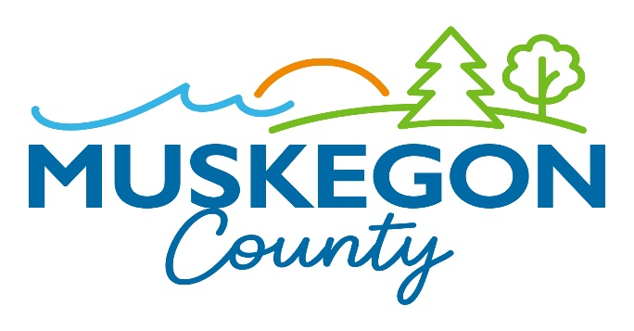
Lori Hayes Karen D. Buie Ivy L. Wiltenburg
Elections Coordinator Muskegon County Clerk Chief Deputy County Clerk

NOTICE TO THE RESIDENTS OF
THE TOWNSHIPS OF BLUE LAKE, CASNOVIA, CEDAR CREEK, EGELSTON, FRUITLAND,
FRUITPORT CHARTER, LAKETON, MONTAGUE, MOORLAND, MUSKEGON CHARTER, RAVENNA, SULLIVAN, WHITE RIVER, AND WHITEHALL; AND THE CITIES OF MONTAGUE, MUSKEGON, MUSKEGON HEIGHTS, NORTH MUSKEGON, NORTON SHORES, ROOSEVELT PARK, AND WHITEHALL

NOTICE IS HEREBY GIVEN pursuant to Michigan Election Law, Public Act 116 of 1954, section 720j(10)(amended), that the February 27, 2024 Presidential Primary Early Voting Closing Board will convene to close the Muskegon County Consolidated Early Voting Site for the Townships of Blue Lake, Casnovia, Cedar Creek, Egelston, Fruitland, Fruitport Charter, Laketon, Montague, Moorland, Muskegon Charter, Ravenna, Sullivan, White River and Whitehall; and the Cities of Montague, Muskegon, Muskegon Heights, North Muskegon, Norton Shores, Roosevelt Park and Whitehall.

Date: Tuesday, February 27, 2024

Time: 8:00 p.m.

Place: Muskegon County Marquette Campus
The Meeting Place
1903 Marquette Avenue
Muskegon, MI 49442
Karen D Buie, Muskegon County Clerk
The County of Muskegon will provide necessary reasonable auxiliary aids and services to individuals with disabilities who want to attend the meeting upon 24-hours notice to the Muskegon County Clerk. Individuals with disabilities requiring auxiliary aids or services should contact the Muskegon County Clerk by writing or calling: Michael E. Kobza Hall of Justice, 990 Terrace Street, 1st Floor, Muskegon, MI 49442 - (231)724-6316.

An EEO/AA Employer

Muskegon County Clerk’s Office | 990 Terrace St., Ste 150, Muskegon, MI 49442 | Ph 231.724.6221
Muskegon Count Circuit Court Records | 990 Terrace St., Ste. 600, Muskegon, MI 49442 | Ph 231.724.6251

